**Experiment No. 1.4**

**Student Name: Rishav Kumar UID: 22MCC20039**

**Branch: MCA - CCD Section/Group: MCD-1/ Grp A**

**Semester: IV Date of Performance: 01st Feb 24**

**Subject Name: Big Data Analytics Subject Code: 22CAP-782**

1. **Aim/Overview of the practical:**

Display the contents of a file in Hadoop and copy it.

1. **Code for practical:**

* Open terminal in Ubuntu and use following command to switch user:
* Start servers using command:

***start-all.sh***

* To view contents of an uploaded file in Hadoop, use command:

***hdfs dfs -cat /hadoopdata/city.txt***

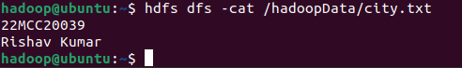

* To copy file to local use copyToLocal command:

***hdfs dfs -copyToLocal /hadoopdata /home/hadoop***

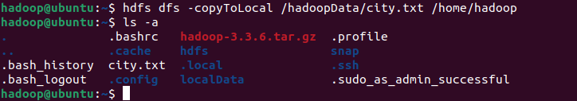

**************************************** **THE END** ***********************************************